## **Elamathi_Day 4_Assignment4**

**--1. List all customers and the products they ordered with the order date. (Inner join)**

SELECT

c.company_name AS customer,

o.order_id,

p.product_name,

od.quantity,

o.order_date

FROM customers c

INNER JOIN orders o ON c.customer_id = o.customer_id

INNER JOIN order_details od ON o.order_id = od.order_id

INNER JOIN products p ON od.product_id = p.product_id;

**OUTPUT:**

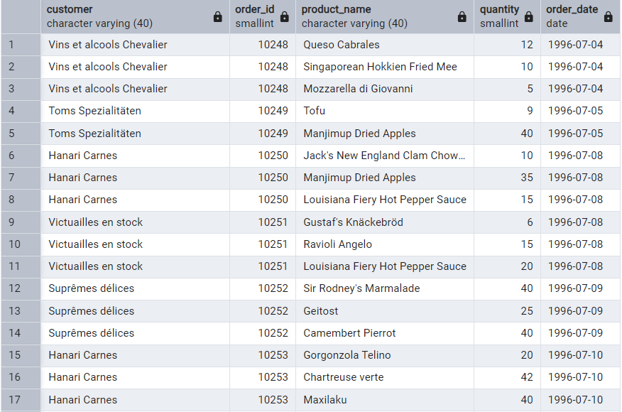

**…………………………………………………………………………………………………………………………………………………………....**

**--2. Show each order with customer, employee, shipper, and product info — even if some parts are missing. (Left Join)**

SELECT

o.order_id,

c.company_name AS customer,

CONCAT (e.first_name, ‘e.last_name) AS employee,

s.company_name AS shipper,

p.product_name,

od.quantity,

o.order_date

FROM orders o

LEFT JOIN customers c ON o.customer_id = c.customer_id

LEFT JOIN employees e ON o.employee_id = e.employee_id

LEFT JOIN shippers s ON o.ship_via = s.shipper_id

LEFT JOIN order_details od ON o.order_id = od.order_id

LEFT JOIN products p ON od.product_id = p.product_id;

**OUTPUT:**

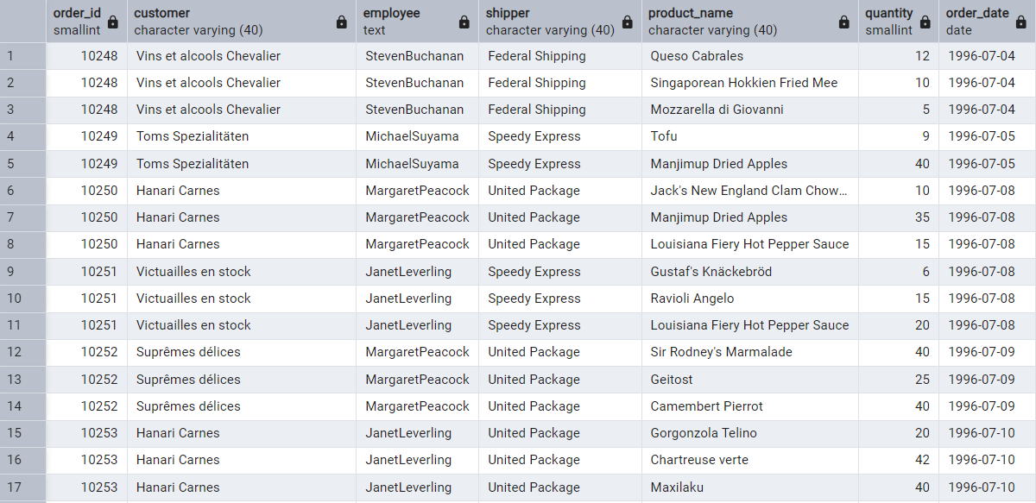

**…………………………………………………………………………………………………………………………………………………………....**

**--3. Show all order details and products (include all products even if they were never ordered). (Right Join)**

od.order_id,

p.product_id,

od.quantity,

p.product_name

FROM order_details od

RIGHT JOIN products p ON od.product_id = p.product_id

**OUTPUT:**

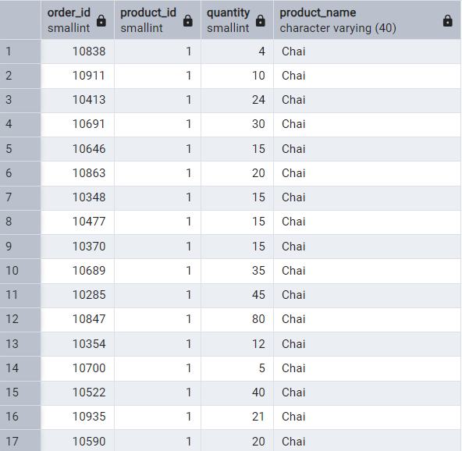

**…………………………………………………………………………………………………………………………………………………………....**

**--4. List all product categories and their products — including categories that have no products, and products that are not assigned to any category. (Outer Join)**

SELECT

c.category_id,

c.category_name,

p.product_id,

p.product_name

FROM categories c

FULL OUTER JOIN products p ON c.category_id = p.category_id;

**OUTPUT:**

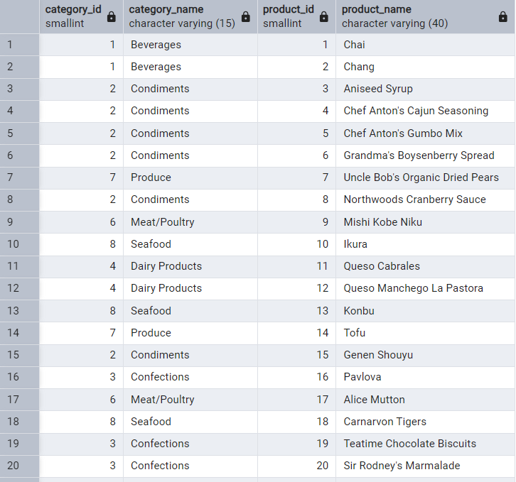

**…………………………………………………………………………………………………………………………………………………………....**

**--5. Show all possible product and category combinations (Cross join).**

SELECT

p.product_id,

p.product_name,

c.category_id,

c.category_name

FROM products p

CROSS JOIN categories c

**OUTPUT:**

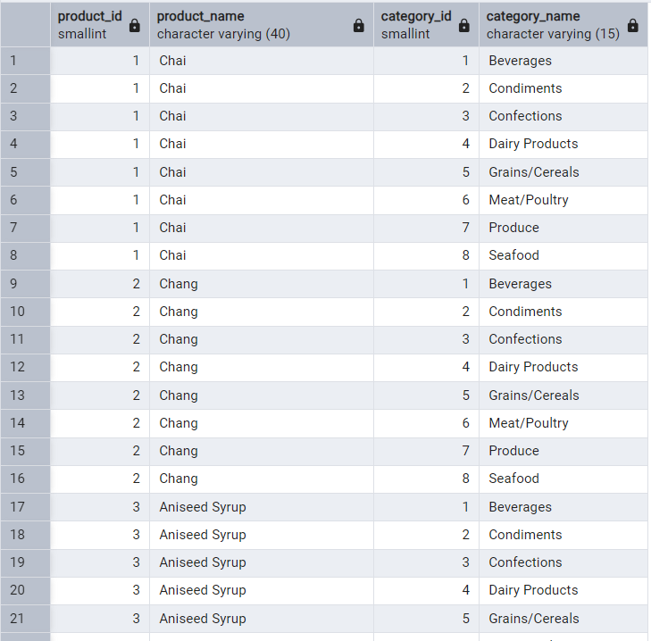

**…………………………………………………………………………………………………………………………………………………………....**

**--6. Show all employees and their manager (Self join (left join))**

SELECT

CONCAT (e.first_name, ' ', e.last_name) AS employee_name,

CONCAT (m.first_name, ' ', m.last_name) AS manager_name

FROM employees e

LEFT JOIN employees m ON e.reports_to = m.employee_id;

**OUTPUT:**

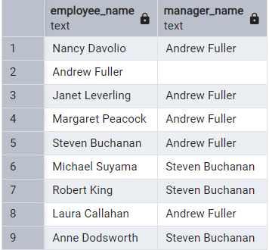

**…………………………………………………………………………………………………………………………………………………………....**

**--7. List all customers who have not selected a shipping method.**

SELECT

c.customer_id,

c.company_name

FROM customers c

LEFT JOIN orders o ON c.customer_id = o.customer_id

WHERE o.ship_via IS NULL;

**OUTPUT:**

